INTERNATIONAL AYURVEDIC MEDICAL JOURNAL

International Ayurvedic Medical Journal (ISSN: 2320 5091) (October - November, 2017) 2(1)

PHARMACOGNOSTICAL AND PHYSICO-CHEMICAL EVALUATION OF MUKKADI YOGA – AN AYURVEDIC OCULAR FORMULATION

Deepak Pawar¹, Haripriya N², Manjusha R³

¹Assistant Professor, Shalakya Tantra, IPGT & RA, GAU, Jamnagar-361008, India
²Assistant Professor, Ahalia Ayurveda Medical College, Palakkad, Kerala-678704, India
³Professor, Shalakya Tantra, AIIA, Delhi-110076, India

Email: drdeep29@gmail.com

Published online: November, 2017
© International Ayurvedic Medical Journal, India 2017

ABSTRACT
Mukkadi yoga is a poly-herbal formulation indicated for Bidalaka (ocular anointment) in inflammatory eye diseases. Aim: The present study deals with the pharmacognostical identification of ingredients of Mukkadi yoga and its physico-chemical analysis. Objective: Pharmacognostical study comprising of both macroscopic and powder microscopy of raw drug revealed the quality and genuineness of all the constituents of Mukkadi yoga. Organoleptic features of coarse powder made out of the crude drugs were within the standards prescribed.

Keywords: Bidalaka, Mukkadi yoga, Organoleptic features, Pharmacognostical, Physicochemical

INTRODUCTION

Ayurveda is enriched with a plenty of simple and useful drug formulations. These are scattered in different samhitas. A timely modification also has been included by the succeeders; but it was fully based on drug availability at those periods. Likewise traditional knowledge of the local vaidyas has been sculpted in different local languages which make most of them inaccessible to the physician community. Thus Standardization has become the need of the hour for Ayurvedic drugs and procedures.
Eye diseases need a systemic approach for cure from the root. But the uniqueness of ophthalmic therapeutic procedures lies in the imperative usage of local therapies; the so called Kriyakalpas. Among this Bidalaka refers to application of medicated paste (in suitable medium) over the eye lid excluding eyelashes¹. It is indicated in Amaja avastha (inflammatory ocular conditions characterized by pain, redness, swellings, discharges etc.) of eye diseases.² Mukkadi yoga is one such formulation explained in Sahasrayogam, a very popular medical text in Malayalam language containing 1000 formulations for different diseases and the formulations are arranged in its dosage form like kwathas, gutikas, churnas etc³. The text in local language also contains clinical features and treatment of diseases over supraclavicular areas. Mukkadi yoga is a vidalaka yoga told in Urdwanga roga chikitsa under the Vartmarogachikitsa prakarana of Sahasrayogam text which is said to be useful in inflammatory signs and symptoms of eye i.e. sopha, ruja, daha, raga etc.⁴ It is widely used in vranasophas of netras like anjana namika, utsangini etc. The contents are predominantly cooling, works on vitiated pitta and rakta and majority have haemostatic activity. Hence it has been selected for trans-dermal absorption as a pittashamaka action.
In view of severe undesirable side effects of synthetic agents, there is growing focus to follow systematic research methodology and to provide scientific basis for the traditional herbal medicines that are claimed to possess effect in eye disorders. The first step for scientifically based research is to provide quality standardization of drug. With this background the present study was undertaken to ascertain the authenticity of all the ingredients of Mukkadi yoga and presence of components as recommended in Ayurvedic Pharmacopoeia of India (API) through pharmacognostical study and physicochemical analysis of the churna yoga⁵.

Material and Methods
Collection of Raw Drug:
Raw drugs for the study were procured from the Pharmacy, I.P.G.T. & R.A., G.A.U., Jamnagar. Only Durva was collected from the campus premises. All these were identified and authenticated in Pharmacognosy Laboratory, IPGT and RA, Gujarat Ayurved University, Jamnagar. The test drug Mukkadi Yoga was prepared as per classical reference of powder formulation (Churna kalpana) and physicochemical and qualitative analysis of the final product was carried out in pharmaceutical chemistry laboratory of IPGT & RA, Jamnagar.

Method of preparation of Mukkadi yoga:
After collecting all the ingredients of Mukkadi yoga, it was finely grinded up to it’s become fine powder form.

Table 1: Ingredients of Mukkadi Yoga
Drug | Botanical name/ chemical name | Part Used | Parts
Hareetaki | Terminalia chebula Retz. | Fruit | 1 part
Amalaki | Embilica officinalis Gaertn | Fruit | 1 part
Vibheetaki | Terminalia bellerica Roxb. | Fruit | 1 part
Gairika | Red ochre feo |  | 1 part
Chandana | Santalum album Linn. | Heart wood | 1 part
Raktha Chandana | Pterocarpus santalinus | Heart wood | 1 part
Haridra | Curcuma longa Linn. | Rhizome | 1 part
Daruharidra | Berberis aristata DC | Rhizome | 1 part
Lodhra | Symplococcus racemosus | Stem bark | 1 part
Sariba | Hemidesmus indicus R Br | Root | 1 part
Vata | Ficus bengalensis | Leaf bud | 1 part
Durva | Cynodon dactylon | Whole plant | 1 part
Useera | Vetivera zizanoidis Linn. | Root | 1 part
Nimba | Azadirachta indica Juss. | Leaves | 1 part

Pharmacognostical evaluation
Dry Powder of the Prayojyaanga of drugs which was used in preparation of Mukkadi Yoga had been used for this study. The root and powder characters were identified with the help of Pharmacognosy laboratory, Institute for Post Graduate Teaching & Research in Ayurveda, Gujarat Ayurved University, Jamnagar, India.
Organoleptic study
Organoleptic characters like texture, taste, odour and colour etc. of Mukkadi Yoga was evaluated in this study (Table 2).

Microscopic Study⁶
The powder was dissolved in small quantity of distilled water, first observed without stain then stained with phloro-glucinol and concentrated HCL⁷. Powder microscopy of Mukkadi Yoga powder was also carried out and microphotographs were taken by Carl zeiss trinocular microscope.

Physico-chemical analysis of Drug⁸
As per the API guideline, Mukkadi yoga was analyzed by using qualitative and quantitative parameters at Pharmaceutical Chemistry Laboratory, Institute for Post Graduate Teaching & Research in Ayurveda, Gujarat Ayurved University, Jamnagar, India.

Results and Discussion
Organoleptic Parameters
Organoleptic characters of Mukkadi Yoga powder are described in the Table No. 2.

Table 2: Organoleptic Properties of Mukkadi Yoga
Rupa (colour ) | Reddish Brown
Rasa (Taste ) | Bitter, Astringent
Gandha (Odour) | Sweet, Sour
Sparsha (Consistency in Touch ) | Fine Powder

Pharmacognostical evaluation
Pharmacognostical features of Mukkadi Yoga powder are showed in Plate no. 1 (Fig.1-24)

Plate 1: Photographs of Microscopic Features Ingredients of Mukkadi Yoga
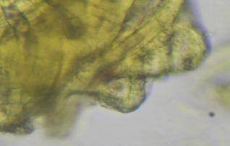 | 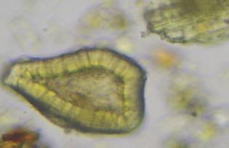 | 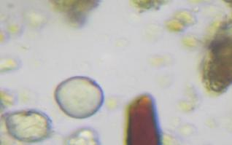
Stone cell of Haritaki | Stone cell of Daruharidra | Oil globule of Chandana
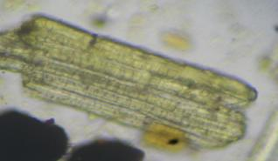 | 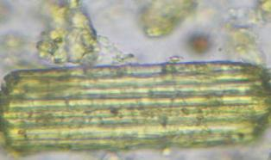 | 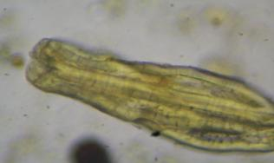
Scleroid of lumen pitted of Bibhitaki | Septate fibre of Usheera | Scleroid of Haritaki
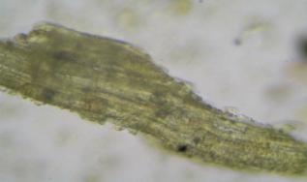 | 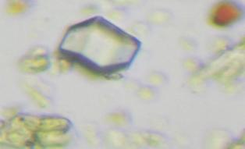 | 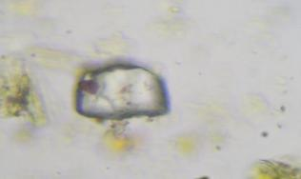
Scleroid of Amalaki | Rhomoid crystal of Sariva | Rhomboid crystal of Lodhra
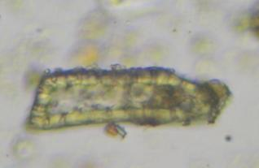 | 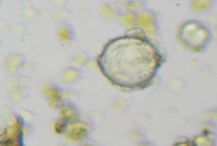 | 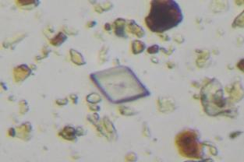
Pitted stone of Vata | Oil globule of Usheera | Prismatic crystal of Daruharidra
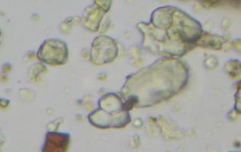 | 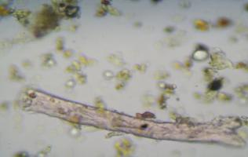 | 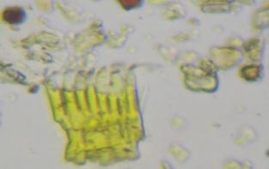
Simple & compound starch cell of Sariva | Lignified hard fibre of Raktachandana | Fragments of border pitted vessel of Daruharidra
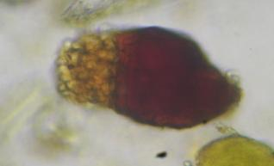 | 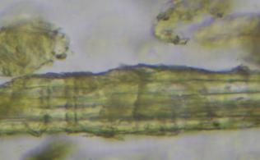 | 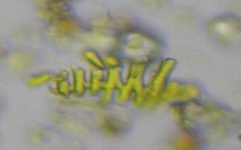
Coloring matter with starch grains of Raktachandana | Fibre passing through medullary rays of Nimba | Fragments of scleleriforum vessel of Haridra
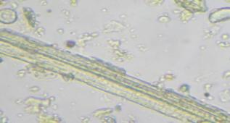 | 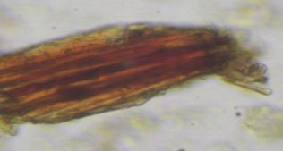 | 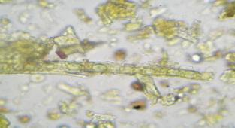
Fibre of Durva | Fibre brown content of Sariva | Crystal fibre of Daruharidra
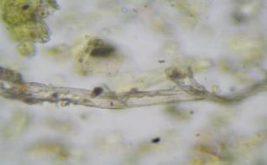 | 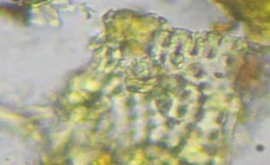 | 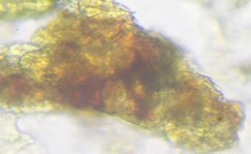
Fibre of Amalaki | Border pitted vessel of Chandana | Cork in surface view of Vata

Physico-Chemical Parameters
Mukkadi yoga was analyzed using various standard physico-chemical parameters such as Loss on drying, Ash value, Water extract value, Alcohol extract value and pH. The results are shown in table no. 3.

Table 3: Physico-Chemical Parameters of Mukkadi Yoga
Sr. no. | Analytical Parameter | Mukkadi yoga
1. | Loss on drying | 0.069%
2. | Ash value | 22.97%
3. | Water Soluble extract value | 0.306 %
4. | Alcohol Soluble extract value | 11%
5. | pH | 4.5

Physico-chemical analysis of the compound revealed loss on drying of test drug is 0.069 % w/w, Ash value of powder is 22.97% w/w, Water soluble extract and alcohol soluble extract is 0.306% w/w & 11.00 % w/w respectively and pH of the compound is 4.5 as shown in table no 3.

High Performance Thin Layer Chromatography (HPTLC)
On performing HPTLC, track showed 8 spots under 254nm with Rf values 0.09, 0.61, 0.67, 0.74, 0.80, 0.86 0.91, 1.00 and 7 spots were seen under 366nm with Rf values 0.06, 0.17, 0.63, 0.67, 0.75, 0.82, 0.88 as depicted in the table no 4. After completion of chromatographic procedure spraying of the plate was done with vanillin sulfuric acid and the spots obtained were observed in day light plate no.2.

Table 4: HPTLC of Mukkadi yoga
Wave Length | No. of spots | Rf value
UV-254 nm | 8 | 0.09, 0.61, 0.67, 0.74, 0.80, 0.86 0.91, 1.00
UV-366 nm | 7 | 0.06, 0.17, 0.63, 0.67, 0.75, 0.82, 0.88

Plate 02: Densitogram - Mukkadi yoga
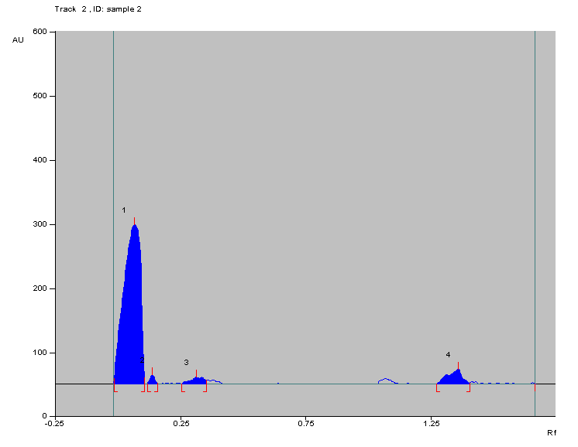 | 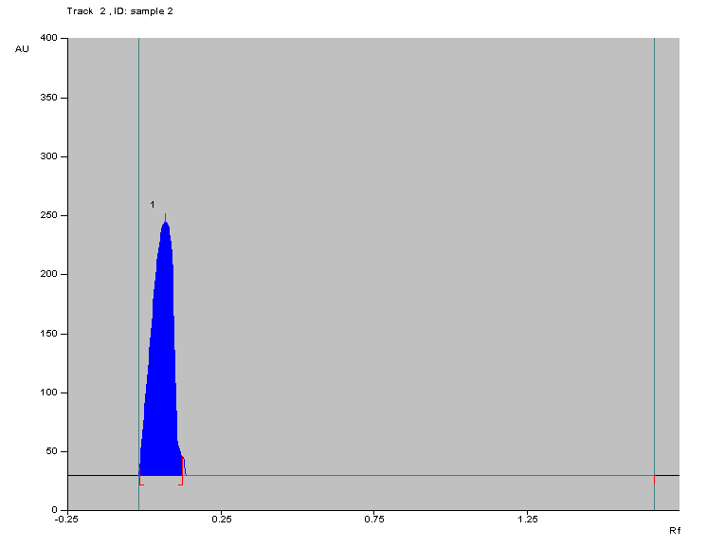

DISCUSSION
Mukkadi yoga is one such formulation explained in Sahasrayogam Netra prakarana Sahasrayogam, which is said to be useful in inflammatory signs and symptoms of eye i.e. sopha, ruja, daha, raga etc. It is widely used in vranasophas of netras like anjana namika,utsangini etc.
The present pharmacognostical study revealed the presence of starch grain cells, tannin and fibers and all these are common in all the ingredients. The presence of all contents of raw drugs in the final product shows the authenticity of the final product.
All the pharmaceutical parameters analyzed showed values permissible for the churna. The Physico-chemical parameters show that percentage of alcohol soluble material is more than water soluble extract. It also shows presence of slightly acidic nature of Churna which may help in augmenting the function of Brajaka Pitta ultimately work as a transdermal action.
HPTLC is the most common form of chromatographic method used by Ayurvedic research workers to detect the number of compounds present in a product. It also helps to determine the purity of the sample. The results shows that the active phytoconstituents are slight equaled sensitive for both UV radiation i.e. 254 nm & 366 nm but by comparison one spot more found in short UV radiation 254 nm.

CONCLUSION
The contents of Mukkadi yoga are predominantly pittashamaka, works on vitiated pitta and rakta and majority have haemostatic activity.
Preliminary organoleptic features and results of microscopy were cross verified with individual raw drug of Mukkadi yoga with the parameters mentioned in Ayurvedic Pharmacopeia of India and all the ingredients were proved to be authentic.
Pharmacognostical evaluation of Mukkadi Yoga illustrated the specific characters of all ingredients which were used in the preparation.

How to cite this URL: Deepak Pawar Et Al: Pharmacognostical And Physico-Chemical Evaluation Of Mukkadi Yoga – An Ayurvedic Ocular Formulation. International Ayurvedic Medical Journal {online} 2017 {cited November, 2017} Available from: http://www.iamj.in/posts/images/upload/776_781.pdf
In physico-chemical analysis, water soluble and alcohol soluble extract, pH, Ash values were assessed. So the pharmacognostical and phyto-chemical analysis of Mukkadi Yoga provides substantial information for the proper identification, authentication, and scientific evaluation of the final product/drug.
On the basis of observations made and results of studies, this study may be beneficial for future researchers and can be used as a reference standard in the further quality control researches.

REFERENCES
- Pt. Parashuram Shatri Vidyasagar, Introduction by Prof. C.B. Jha, Sharangadhar Samhita, 2006, Chaukhamba Surbharati Prakashan, page no. 383
- Vaidya Jadavaji Trikamji Acharya, Charak Samhita, 2009, Chaukhamba Surbharati Prakashan, page no. 610
- K.V. Krishnan Vaidyan & S. Gopala Pillai, Sahasrayogam, 33rd edition, Vidyarambham Publishers, Mullakkal, Alappuzha; Feb 2015, page no. 381
- K.V. Krishnan Vaidyan & S. Gopala Pillai, Sahasrayogam, 33rd edition, Vidyarambham Publishers, Mullakkal, Alappuzha; Feb 2015, page no. 381
- The Ayurvedic Pharmacopea of India, 2007, 1st edition, Part 2, Volume 1;appendix 2; 14
- Wallis TE., Text Book of Pharmacognosy. 5th edition, New Delhi: CBS Publishers; 1985, page no. 571-8.
- Khandelwal K.R., Practical Pharmacognosy, Pune: Nirali Prakashan; 2008, page no. 149-66
- The Ayurvedic Pharmacopea of India, 2007, 1st edition, Govt. of India, Part 2, Volume 1;appendix 2, 14

Source of Support: Nil
Conflict Of Interest: None Declared

